

**Dr. D.Y. Patil School of MCA**

***Charoli (BK), PUNE-******412105***

**SAVITRIBAI PHULE PUNE UNIVERSITY**

# MASTER OF COMPUTER APPLICATION

**Project Report on**

**“DDOS Attack Detection“**

**Under The Guidance Of**

**“Prof. Sapna Chavan“**

**BY**

# “Name : Sachin Lohar Seat No. : 267“

**Class : MCA-II ( Sem-IV)**

**Year : 2023-2024**

Date:-

**CERTIFICATE**

**This is to certify that Mr. / Ms. Sachin Bharat Lohar, has successfully / partially completed his/her project work entitled “DDOS Attack Detection System” in partial fulfillment of MCA -II SEM-III Mini Project for the year 2023-2024. He / She have worked under our guidance and direction.**

**Place : Pune**

**Date :**

**Prof.** **Sapna Chavan Prof. Santosh Deshmukh Dr. E. B. Khedkar**

**(Project Guide) HOD DYPSOMCA (Director,DYPSOMCA)**

**Index**

|  |  |  |
| --- | --- | --- |
| **Chapter No.** | **Particulars** | **Page**  **Number** |
| **1** | **INTRODUCTION** |  |
| 1.1 | INTRODUCTION |  |
| 1.2 | EXISTING SYSTEM AND LIMITATIONS OF THE EXISTING  SYSTEM |  |
| 1.3 | NEED FOR THE PROPOSED SYSTEM |  |
| **2** | **PROPOSED SYSTEM** |  |
| 2.1 | PROBLEM STATEMENT |  |
| 2.2 | OBJECTIVES OF PROPOSED SYSTEM |  |
| 2.3 | FUNCTIONAL AND NON-FUNCTIONAL REQUIREMENTS |  |
| 2.4 | SCOPE OF THE SYSTEM |  |
| 2.5 | MODULE SPECIFICATION |  |
| 2.6 | OPERATING ENVIRONMENT |  |
| **3** | **REQUIREMENT DETERMINATION AND ANALYSIS** |  |
| 3.1 | FACT FINDING METHODS |  |
| 3.2 | FEASIBILITY STUDY |  |
| **4** | **SYSTEM ANALYSIS AND DESIGN** |  |
| 4.1 | ENTITY RELATIONSHIP DIAGRAM |  |
| 4.2 | USE CASE DIAGRAM |  |
| 4.3 | CLASS DIAGRAM |  |
| 4.4 | SEQUENCE DIAGRAM |  |
| 4.5 | ACTIVITY DIAGRAM |  |
| 4.6 | MODULE HIERARCHY DIAGRAM |  |
| 4.7 | COMPONENT DIAGRAM |  |
| 4.8 | DEPLOYMENT DIAGRAM |  |
| 4.9 | WEB SITE MAP DIAGRAM |  |
| 4.10 | TABLE SPECIFICATION [DATA DICTIONARY] |  |
| 4.11 | USER INTERFACE DESIGN AND REPORTS |  |
| **5** | **DRAWBACKS AND LIMITAION** |  |
| **6** | **PROPOSED ENHANSMENT** |  |
| **7** | **CONCLUSION** |  |
| **8** | **BIBILOGRAPHY** |  |
| **9** | **ANNEXURES** |  |
| **10** | **SAMPLE CODE** |  |

1. **INTRODUCTION**

**1.1. INTRODUCTION**

The DDOS Attack Detection System is a Python-based solution designed to identify and mitigate Distributed Denial of Service (DDOS) attacks on networks. Leveraging machine learning algorithms like Support Vector Machine (SVM) and Random Forest (RF), the system analyses network traffic data to distinguish between normal and malicious activities. Users can train the system using labelled datasets, and it employs trained models to detect potential DDOS attacks in real-time.

The system offers a user-friendly interface for training models, testing against new data, and displaying detection outcomes. With its capability to differentiate DDOS attacks from regular network traffic, it enhances network security and aids in timely response to potential threats. This SRS document outlines the functional and non-functional requirements, system architecture, and user interactions for the DDOS Attack Detection System.

**1.2. EXISTING SYSTEM AND LIMITATIONS OF THE EXISTING SYSTEM**

**Existing System:**

Traditional DDOS detection methods rely heavily on manual monitoring and rule-based systems, which are often inadequate for identifying sophisticated attacks. These methods lack scalability and real-time detection capabilities, leading to delayed response times and increased vulnerability. Moreover, they require extensive human intervention for analysis and decision-making. The DDOS Attack Detection System addresses these limitations by automating the detection process using machine learning algorithms, enhancing efficiency and accuracy in identifying DDOS attacks.

**Limitations of the Existing System:**

1. Manual Intervention: Traditional DDOS detection systems heavily depend on manual monitoring and intervention, which makes them inefficient and slow in responding to attacks. Human operators are required to analyze network traffic patterns and identify anomalies, leading to delays in threat detection and mitigation.

2. Rule-Based Approach: Many existing systems utilize rule-based approaches for DDOS detection, which involve defining specific patterns or signatures of attacks. However, these rules are often static and unable to adapt to evolving attack techniques. As a result, they may fail to detect newly emerging threats or sophisticated attack vectors.

3. Scalability Issues: Traditional systems may struggle to handle the increasing volume and complexity of network traffic, especially in large-scale networks. Scaling up these systems to accommodate growing traffic loads can be challenging and may result in performance degradation or resource limitations.

4. Limited Real-Time Detection: Due to their reliance on manual analysis and predefined rules, existing systems may lack real-time detection capabilities. This delay in detection can allow DDOS attacks to inflict significant damage on network resources and disrupt services before they are identified and mitigated.

5. High False Positive Rates: Rule-based DDOS detection systems are prone to generating false positives, where legitimate traffic is misclassified as malicious. This can lead to unnecessary alerts and resource wastage as security teams investigate non-existent threats, reducing the overall effectiveness of the system in detecting genuine attacks.

**1.3. NEED FOR THE PROPOSED SYSTEM**

The proposed DDOS Attack Detection System addresses the limitations of the existing systems and aims to provide an enhanced user experience by offering personalized and accurate Detections. Here are the key needs for the proposed system:

1. The proposed DDOS Attack Detection System aims to improve detection accuracy by leveraging machine learning algorithms. Unlike traditional rule-based systems, machine learning models can dynamically adapt to changing attack patterns and identify subtle anomalies in network traffic, resulting in more reliable detection outcomes and reduced false positive rates.

2. Real-Time Detection: With the increasing prevalence of sophisticated and rapidly evolving DDOS attacks, there is a critical need for real-time detection capabilities. The proposed system offers timely identification of DDOS threats, allowing for immediate mitigation measures to be implemented, thereby minimizing the impact of attacks on network resources and services.

3. Automated Detection: By automating the detection process using machine learning models, the proposed system reduces reliance on manual intervention and human expertise. This automation enhances efficiency and scalability, enabling the system to analyze large volumes of network traffic in real-time and detect DDOS attacks with minimal delay.

4. Scalability and Adaptability: Traditional DDOS detection systems often struggle to scale up to handle the growing volume and complexity of modern network traffic. The proposed system addresses this challenge by utilizing machine learning algorithms that are inherently scalable and adaptable. This ensures that the system can effectively analyze traffic patterns in both small-scale and large-scale networks, accommodating future growth and evolution.

1. **PROPOSED SYSTEM**

**2.1. PROBLEM STATEMENT**

In the current landscape of cybersecurity, Distributed Denial of Service (DDOS) attacks pose a significant threat to network infrastructure and services. Traditional DDOS detection systems rely on manual monitoring and rule-based approaches, leading to inefficiencies, delayed response times, and limited scalability. These systems often struggle to adapt to evolving attack techniques and may generate high false positive rates, hindering effective threat mitigation.

Moreover, the increasing volume and complexity of network traffic exacerbate the challenges faced by existing DDOS detection systems, further underscoring the need for a more advanced and automated approach to threat detection and mitigation. Therefore, there is a pressing need for a robust DDOS Attack Detection System that leverages machine learning algorithms to analyse network traffic patterns, identify potential threats in real-time, and facilitate prompt response and mitigation measures. Such a system would enhance the security posture of networks, reduce the impact of DDOS attacks on network resources and services, and ensure the continuity of operations for organizations in the face of cyber threats.

**2.2. OBJECTIVES OF PROPOSED SYSTEM**

The primary objective of the proposed DDOS Attack Detection System is to enhance the efficacy and efficiency of DDOS threat detection and mitigation through the utilization of machine learning algorithms. By leveraging advanced algorithms such as Support Vector Machine (SVM) and Random Forest (RF), the system aims to achieve the following objectives:

1. Real-Time Detection: The system seeks to detect DDOS attacks in real-time, enabling immediate response and mitigation measures to minimize the impact of attacks on network resources and services. Through continuous monitoring and analysis of network traffic patterns, the system can swiftly identify anomalies indicative of potential DDOS attacks.

2. Reduced False Positives: By employing machine learning models trained on labeled datasets, the system aims to reduce false positive rates associated with traditional rule-based DDOS detection methods. This enhanced accuracy ensures that genuine threats are promptly identified, while minimizing unnecessary alerts and resource wastage.

3. Scalability and Adaptability: The proposed system is designed to be scalable and adaptable to varying network environments and traffic loads. It can effectively analyze traffic patterns in both small-scale and large-scale networks, accommodating future growth and evolution without compromising performance or detection accuracy. This scalability ensures that the system remains effective in mitigating DDOS attacks across diverse network infrastructures and configurations.

**2.3. FUNCTIONAL AND NON-FUNCTIONAL REQUIREMENTS**

**Functional Requirements:**

1. Data Preprocessing: The system should preprocess incoming network traffic data, including features such as duration, protocol type, and service, to ensure compatibility with machine learning algorithms. This may involve data normalization, encoding categorical variables, and handling missing values.

2. Model Training: The system must train machine learning models, such as Support Vector Machine (SVM) and Random Forest (RF), using labelled datasets containing examples of normal and DDOS traffic. Training should involve feature selection, model fitting, and evaluation to ensure optimal performance.

3. Real-Time Detection: Upon deployment, the system should continuously monitor network traffic and analyse patterns in real-time using the trained models. It should promptly detect anomalies indicative of potential DDOS attacks and trigger alerts or mitigation actions accordingly.

4. Alerting Mechanism: The system should provide an alerting mechanism to notify network administrators or security personnel of detected DDOS attacks. Alerts should include relevant information such as attack type, severity, and affected resources.

5. Mitigation Strategies: Upon detecting a DDOS attack, the system should initiate predefined mitigation strategies to minimize its impact on network operations. This may include traffic filtering, rate limiting, or rerouting traffic to mitigate the effects of the attack.

**Non-Functional Requirements:**

1. Performance: The system should exhibit high performance, with minimal latency in processing network traffic data and detecting DDOS attacks. It should be capable of handling large volumes of traffic efficiently, even under peak load conditions.

2. Scalability: The system should seamlessly expand to support growing network infrastructures and traffic volumes, scaling horizontally with added computational resources or vertically through algorithm and processing optimization.

3. Reliability: The system should be highly reliable, ensuring continuous operation and minimal downtime. It should be resilient to failures and errors, with mechanisms in place for fault tolerance, error handling, and graceful degradation.

4. Security: The system must meet rigorous security standards, employing encryption, authentication, and access controls to safeguard data integrity and confidentiality, mitigating unauthorized access or tampering.

5. Usability: The system should have a user-friendly interface, allowing network administrators to easily configure, monitor, and manage DDOS detection and mitigation activities. It should provide clear and intuitive visualizations, alerts, and reports to facilitate effective decision-making.

**2.4. SCOPE OF THE SYSTEM**

The scope of the DDOS Attack Detection System encompasses the following aspects:

1. DDOS Detection and Mitigation: The system's primary scope includes the detection and mitigation of Distributed Denial of Service (DDOS) attacks on network infrastructures. It analyses incoming network traffic in real-time, identifying anomalies indicative of potential attacks, and initiates appropriate mitigation strategies to minimize their impact.

2. Machine Learning-Based Detection: Leveraging machine learning algorithms such as Support Vector Machine (SVM) and Random Forest (RF), the system enhances the accuracy and efficiency of DDOS detection. It trains models using labelled datasets to recognize patterns of normal and malicious traffic, enabling proactive identification of DDOS threats.

3. Real-Time Monitoring and Alerting: The system continuously monitors network traffic patterns, providing real-time alerts upon detecting suspicious activities or anomalies. It promptly notifies network administrators or security personnel, facilitating immediate response and mitigation actions to mitigate the effects of DDOS attacks.

4. Scalability and Adaptability: Designed to accommodate varying network infrastructures and traffic loads, the system is scalable and adaptable. It can efficiently analyse traffic patterns in both small-scale and large-scale networks, ensuring effective DDOS detection and mitigation across diverse environments.

**2.5.** **MODULE SPECIFICATION**

**1.** **Data Preprocessing Module:**

* This module is responsible for preprocessing incoming network traffic data, including normalization, encoding categorical variables, and handling missing values, to ensure compatibility with machine learning algorithms.

**2.** **Model Training Module:**

* The Model Training module trains machine learning models such as Support Vector Machine (SVM) and Random Forest (RF) using labelled datasets containing examples of normal and DDOS traffic. It involves feature selection, model fitting, and evaluation to ensure optimal performance.

**3.** **Real-Time Detection Module:**

* This module continuously monitors network traffic patterns in real-time using the trained models. It swiftly identifies anomalies indicative of potential DDOS attacks and triggers alerts or mitigation actions accordingly.

**4.** **Alerting and Reporting Module:**

* The Alerting and Reporting module provides an alerting mechanism to notify network administrators or security personnel of detected DDOS attacks. It also maintains logs of detected attacks and generates reports summarizing attack details, impact, and mitigation measures for further analysis and auditing purposes.

**2.6.** **OPERATING ENVIRONMENT**

The Online Movie Recommendation System operates within a specific environment that includes the following components:

**1.** **Hardware:**

* The system operates on standard hardware commonly found in enterprise network environments. It requires servers or virtual machines with adequate processing power, memory, and storage capacity to handle the computational demands of real-time traffic analysis and machine learning algorithms.
* Additionally, network infrastructure components such as routers, switches, and firewalls play a crucial role in facilitating data transmission and traffic monitoring.

**2.Software:**

* Operating System: The server and client devices must have compatible operating systems such as Windows, macOS, or Linux.
* Backend: The system utilizes the Python Language, which requires compatible versions of Python and its dependencies.
* Machine Learning Libraries: Python libraries such as scikit-learn are utilized for implementing machine learning algorithms.
* Frontend Technologies: The user interface is built using GUI Technology Tkinter for interactive and responsive designs.

**3. Network:**

* The system operates within a network environment consisting of interconnected devices such as servers, routers, switches, and endpoints. It leverages network protocols for data transmission and communication between components.
* Additionally, it may utilize network monitoring tools for capturing and analysing network traffic in real-time.

**4.Dependencies:**

* The system may depend on external libraries and frameworks for machine learning, such as scikit-learn, NumPy, Pandas and Joblib, for implementing algorithms and model training.
* It may also rely on network monitoring tools or packet capture utilities for collecting and analysing network traffic data. Additionally, access to labelled datasets for training machine learning models is essential for effective DDOS detection.

The operating environment of the DDOS Attack Detection System involves the hardware, software, network infrastructure, and dependencies necessary for its proper functioning. It is essential to ensure that the operating environment meets the system requirements and that all components are compatible and properly configured to deliver a seamless user experience.

**3.** **REQUIREMENT DETERMINATION AND ANALYSIS**

**3.1.** **FACT FINDING METHODS**

Fact-finding methods are techniques used to gather information and gain a deep understanding of the system requirements, user needs, and organizational processes. Here are some commonly used fact-finding methods:

1. Interviews: Conducting interviews with stakeholders, including network administrators, security personnel, and system users, helps gather firsthand information about their experiences, challenges, and requirements related to DDOS attack detection and mitigation. Structured interviews can provide valuable insights into specific system functionalities and user expectations.
2. Surveys: Distributing surveys among a broader audience, such as network engineers, IT professionals, and cybersecurity experts, allows for collecting quantitative data on various aspects of DDOS attacks and existing detection mechanisms. Surveys can help identify common trends, preferences, and concerns within the user community.
3. Document Review: Reviewing existing documentation, including network diagrams, system specifications, and incident reports, provides a comprehensive understanding of the current infrastructure, operational procedures, and historical DDOS attack incidents. Analysing documentation helps identify areas for improvement and informs the development of system requirements.
4. Observation: Observing the day-to-day operations of network administrators and security teams in managing network traffic and responding to potential DDOS attacks offers valuable insights into workflow processes, tools usage, and challenges faced in real-world scenarios. Direct observation allows for identifying inefficiencies and bottlenecks in existing practices.
5. Prototype Evaluation: Developing prototypes or mock-ups of the DDOS detection system and conducting usability testing sessions with end-users enables feedback collection on system functionality, interface design, and user experience. Prototype evaluation helps validate system requirements, identify usability issues, and prioritize feature enhancements.
6. Expert Consultation: Seeking advice and insights from domain experts, such as cybersecurity consultants, data scientists, and machine learning specialists, can provide valuable guidance on system design, algorithm selection, and best practices for DDOS attack detection. Expert consultation ensures that the system incorporates industry-leading techniques and methodologies.

By employing these fact-finding methods, analysts can gather accurate and comprehensive information about system requirements, user expectations, and organizational processes. This information serves as a foundation for designing and developing a system that meets the needs and expectations of all stakeholders involved.

**3.2.** **FEASIBILITY STUDY**

A feasibility study is conducted to evaluate the viability and practicality of a proposed project or system. It assesses various aspects, including technical, economic, operational, and scheduling feasibility, to determine if the project is feasible and worth pursuing. Here are the key components of a feasibility study:

**1.** **Technical Feasibility:**

* Assessing Technological Capability: Evaluating whether the required technology, infrastructure, and resources are available or can be acquired to develop and implement the proposed system.
* Analysing Compatibility: Ensuring compatibility with existing systems, databases, and platforms to facilitate integration and seamless operation.

**2.** **Economic Feasibility:**

* Cost-Benefit Analysis: Determining the project's costs, including development, implementation, training, maintenance, and operational expenses, and comparing them to the expected benefits and potential return on investment.
* Return on Investment (ROI): Estimating the financial gains and benefits that can be achieved from the proposed system and determining if they justify the project's costs.
* Payback Period: Calculating the time required for the project to recover its initial investment and start generating profits or benefits.

**3.** **Operational Feasibility:**

* Assessing Organizational Readiness: Evaluating if the organization has the necessary resources, skills, and capacity to support and effectively use the proposed system.
* Impact on Existing Processes: Analysing the impact of the system on current business processes, workflows, and operations, and determining if the proposed changes can be effectively implemented and managed.

**4.** **Scheduling Feasibility:**

* Project Timeline: Estimating the time required for system development, testing, implementation, and deployment, and assessing if the project can be completed within the desired timeframe.
* Resource Availability: Evaluating the availability of human resources, expertise, and external dependencies required for the project and ensuring that they can be obtained in a timely manner.

**5.** **Legal and Ethical Feasibility:**

* Compliance with Laws and Regulations: Assessing if the proposed system complies with relevant laws, regulations, data privacy, and security requirements.

Based on the findings of the feasibility study, project stakeholders can make informed decisions regarding the project's viability and feasibility.

**4. SYSTEM ANALYSIS AND DESIGN**

**4.2. USE CASE DIAGRAM**

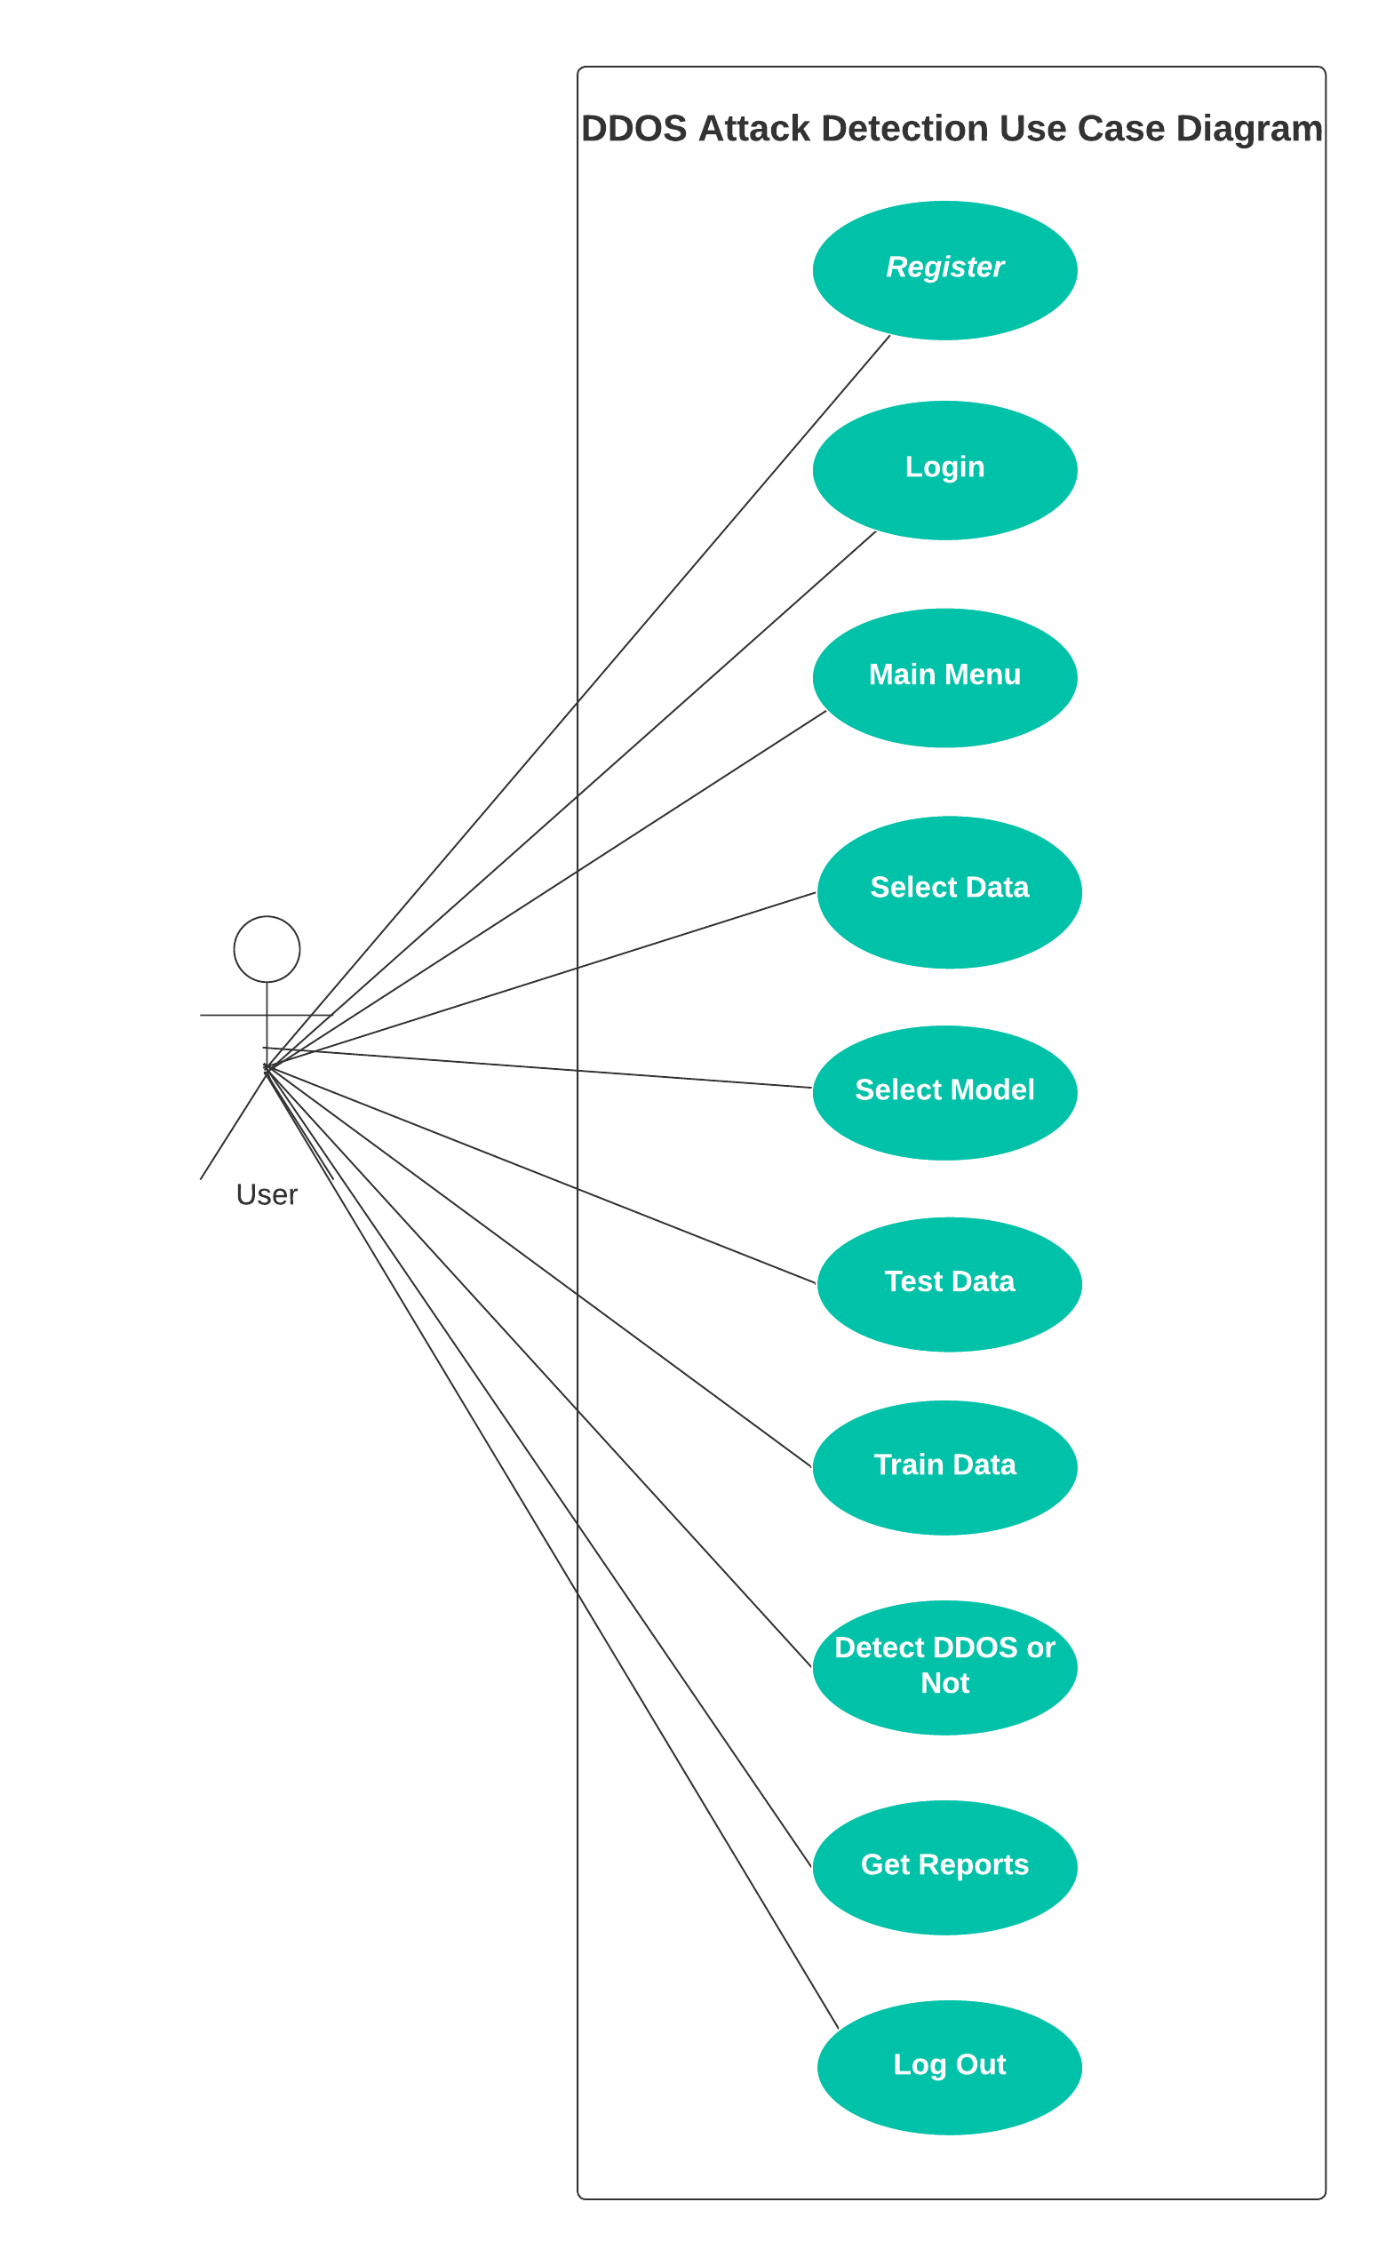

**4.4. SEQUENCE DIAGRAM**

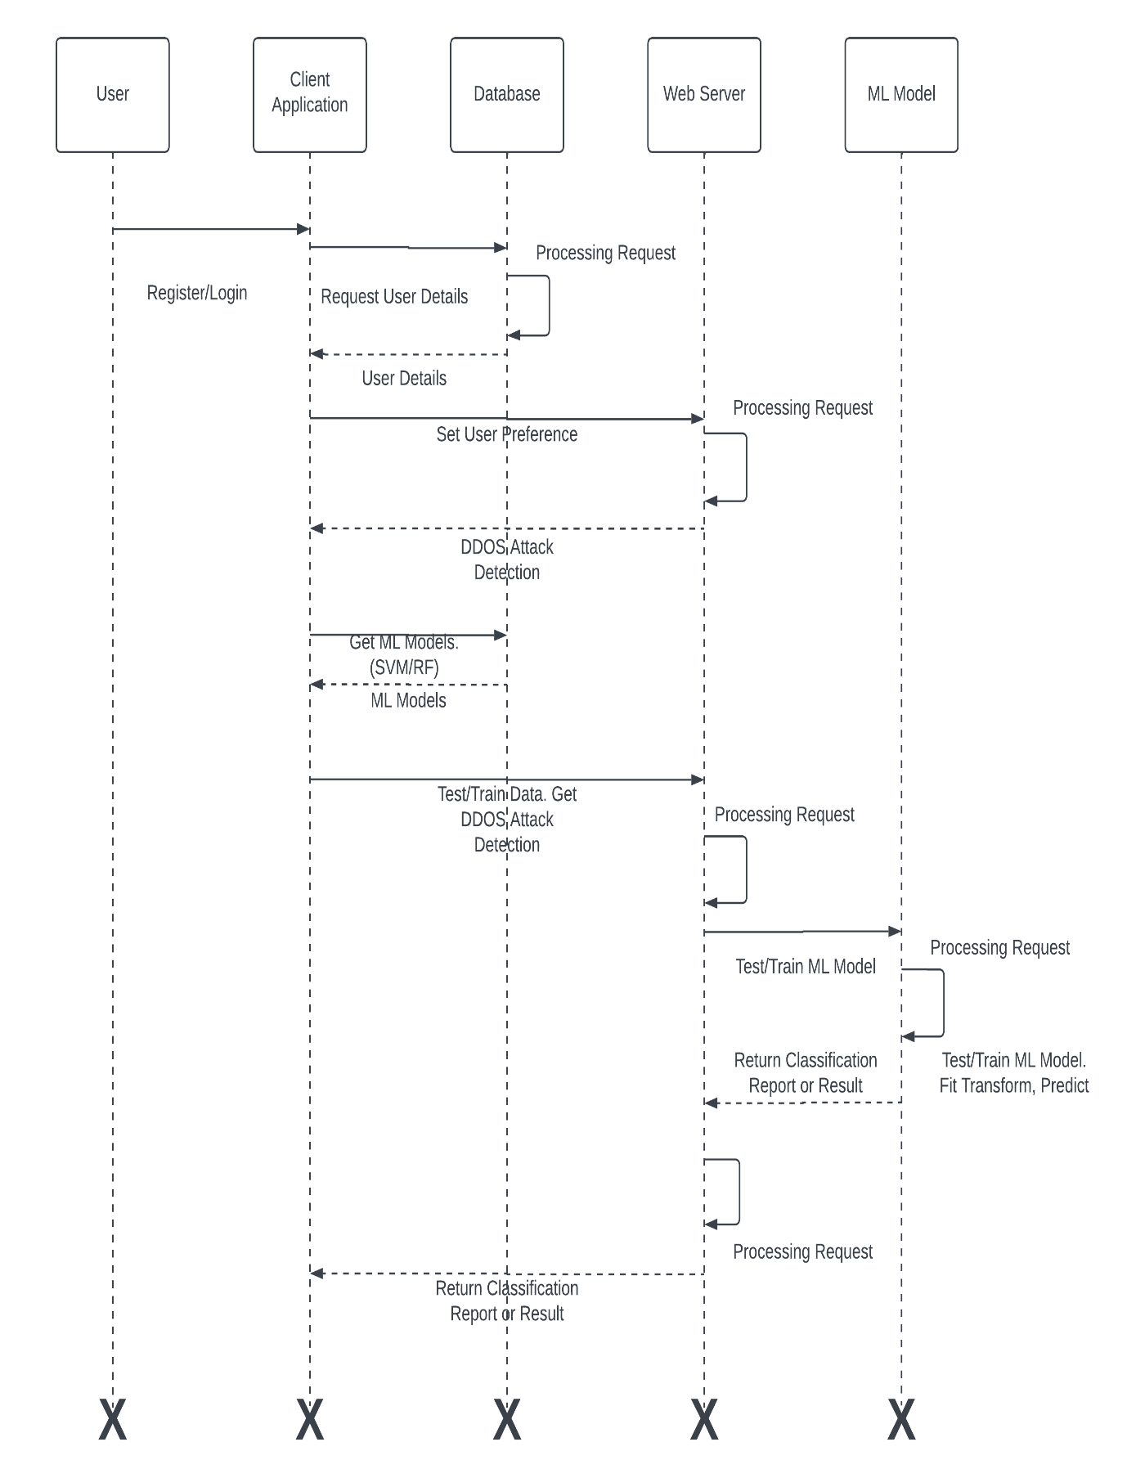

**4.5. ACTIVITY DIAGRAM**

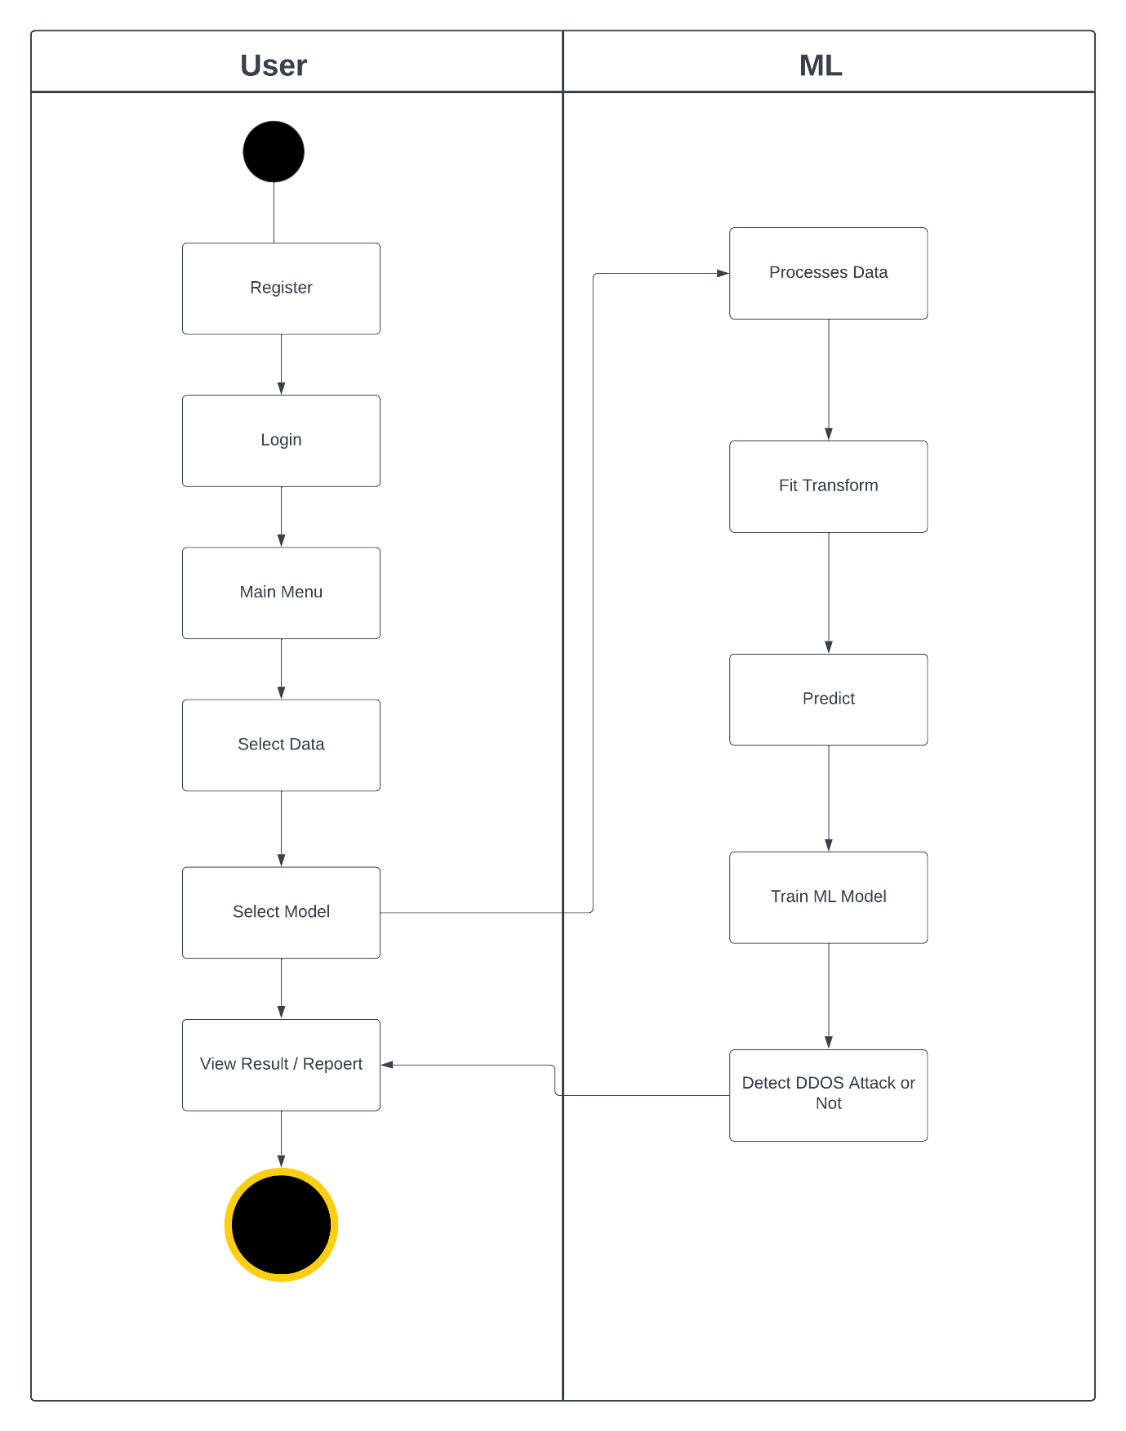

**4.6. ARCHITECTURE DIAGRAM**

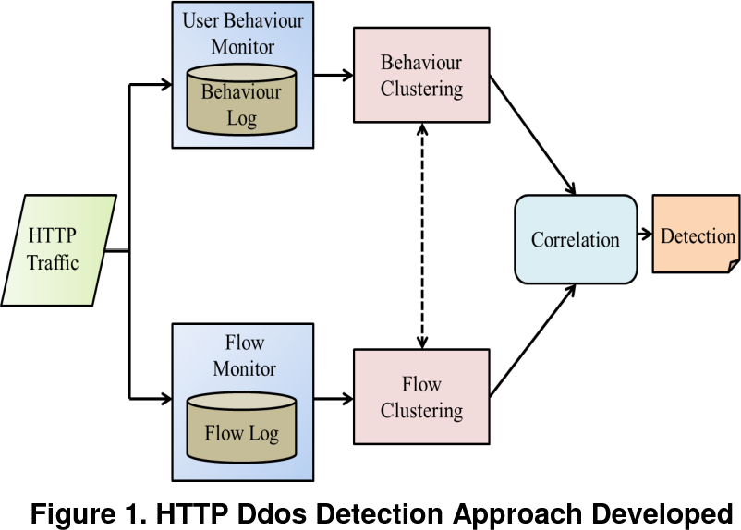

**4.11. USER INTERFACE DESIGN AND REPORTS**

**Register Page :**

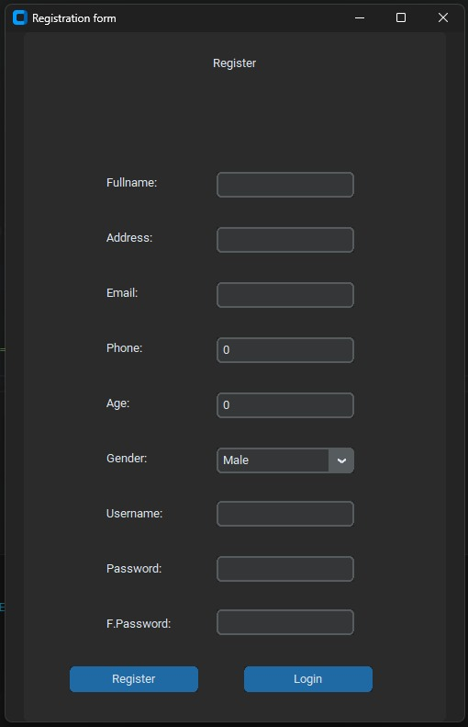

**Login Page :**

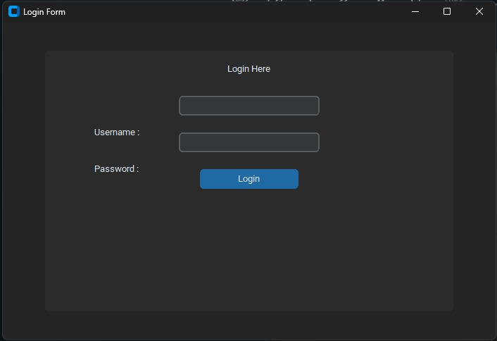

**Home Page :**

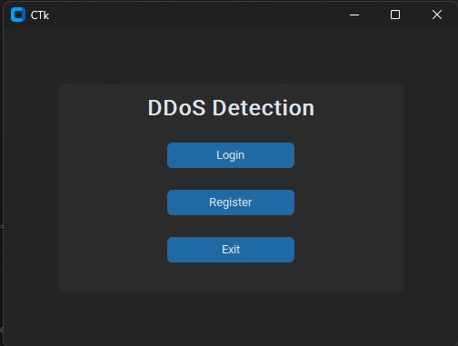

**Main Page :**





**DDOS Detection Page :**





**DDOS Detection Page :**





**Model Train Page :**

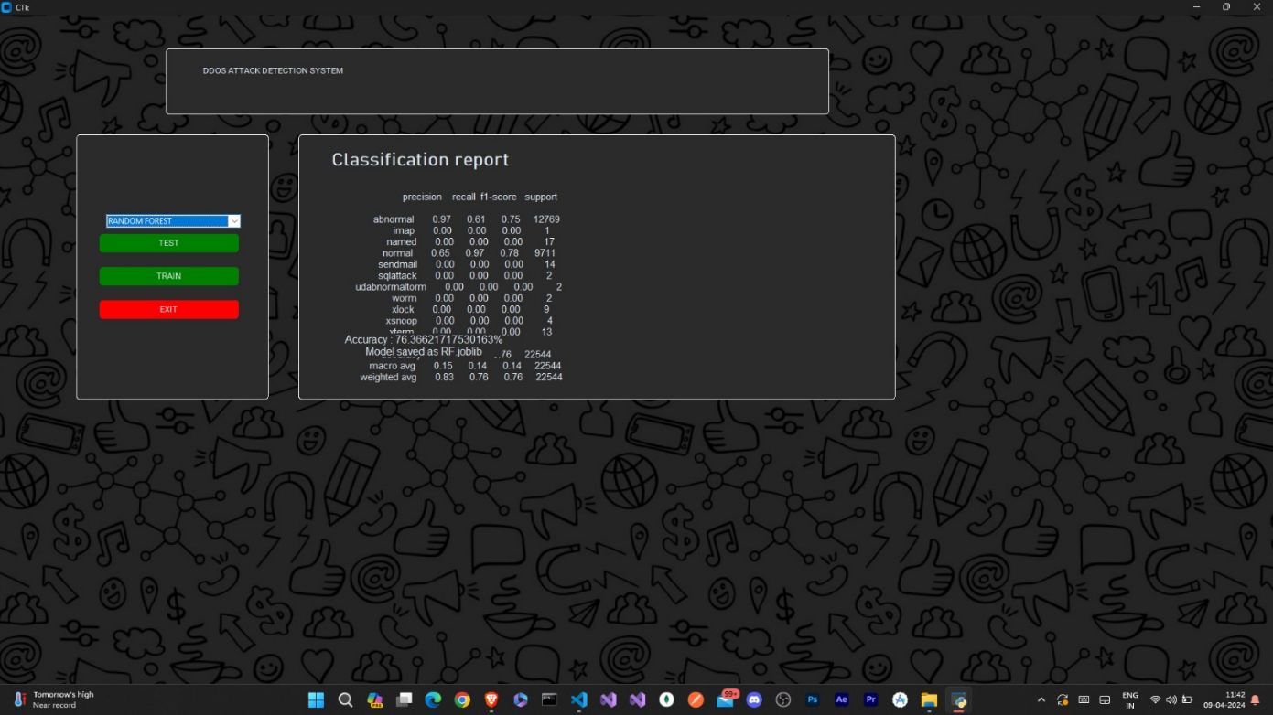

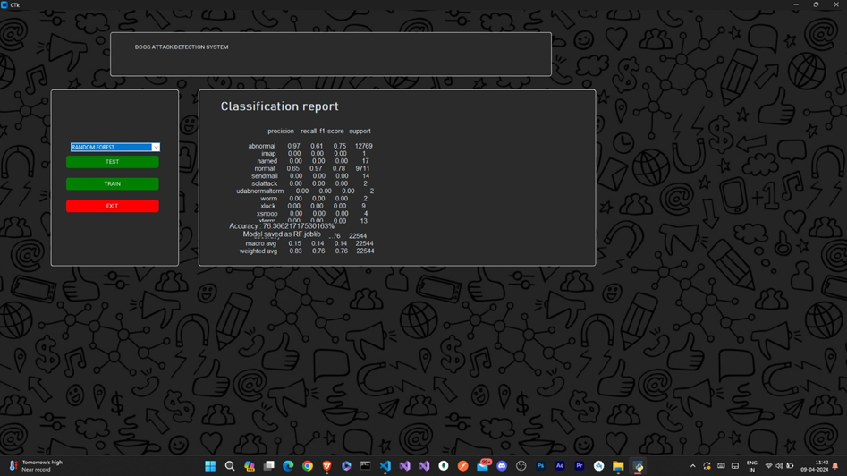

**5.** **DRAWBACKS AND LIMITAION**

**1.** **Dependency on Labelled Datasets:** The effectiveness of machine learning-based DDOS detection hinges on the availability and quality of labelled datasets for model training. However, acquiring sufficiently large and diverse datasets that accurately represent DDOS attack scenarios can be challenging. Limited or biased datasets may result in suboptimal model performance and reduced detection accuracy, especially for detecting novel or evolving attack patterns.

**2. Algorithm Complexity and Resource Requirements:** Machine learning algorithms used for DDOS detection, such as Support Vector Machine (SVM) and Random Forest (RF), can be computationally intensive and resource-demanding, particularly during model training and real-time inference. This complexity may necessitate high-performance hardware infrastructure and incur significant computational costs, limiting the scalability and practical feasibility of deploying the system in resource-constrained environments.

**6.** **PROPOSED ENHANSMENT**

To address the limitations and improve the DDOS Attack Detection System, several enhancements can be considered:

1. **Integration of Anomaly Detection Techniques:** Augmenting the system with advanced anomaly detection techniques, such as unsupervised learning algorithms or deep learning models, can improve its ability to detect subtle deviations from normal network behaviour. By complementing supervised learning approaches, the system can enhance its detection capabilities, especially for detecting previously unseen or zero-day DDOS attacks.
2. **Dynamic Model Updating:** Implementing a mechanism for dynamic model updating allows the system to continuously adapt to changing network conditions and evolving attack patterns. By periodically retraining machine learning models with the latest labelled data, the system can maintain optimal detection accuracy and responsiveness, ensuring robust performance in dynamic environments.
3. **Integration with Threat Intelligence Feeds:** Integrating the system with external threat intelligence feeds and security information and event management (SIEM) systems enriches its threat detection capabilities. By leveraging real-time threat intelligence data, such as known attack signatures or indicators of compromise, the system can enhance its ability to identify and mitigate DDOS attacks more effectively.
4. **Automated Response Orchestration:** Enhancing the system with automated response orchestration capabilities enables it to autonomously initiate predefined mitigation actions in response to detected DDOS attacks. By integrating with network infrastructure components, such as firewalls or intrusion detection systems, the system can automatically implement traffic filtering, rate limiting, or traffic redirection strategies, minimizing manual intervention and reducing response times during attack incidents.

By incorporating these enhancements, the DDOS Attack Detection System can provide more accurate, and diverse Detections, leading to an enhanced user experience, increased user engagement, and improved user satisfaction.

**7. CONCLUSION**

In conclusion, the proposed DDOS Attack Detection System represents a significant advancement in cybersecurity technology, offering a proactive and efficient approach to mitigating the growing threat of DDOS attacks in network infrastructures. By leveraging machine learning algorithms such as Support Vector Machine (SVM) and Random Forest (RF), the system enhances detection accuracy and responsiveness, enabling timely identification and mitigation of DDOS threats.

Furthermore, the system's real-time monitoring capabilities and automated alerting mechanism empower network administrators and security personnel to swiftly respond to detected DDOS attacks, minimizing the impact on network resources and services. The integration of anomaly detection techniques and dynamic model updating ensures that the system remains adaptive and resilient to evolving attack patterns, providing robust protection against both known and emerging threats.

Moreover, the proposed enhancements, including the integration with threat intelligence feeds and automated response orchestration, further strengthen the system's capabilities, enhancing its effectiveness in detecting and mitigating DDOS attacks across diverse network environments. By leveraging external threat intelligence data and automating response actions, the system can proactively identify and mitigate DDOS attacks, reducing manual intervention and response times during attack incidents.

Overall, the proposed DDOS Attack Detection System offers a comprehensive solution to the challenges posed by DDOS attacks, providing network administrators with the tools and capabilities needed to safeguard network infrastructure and services against malicious threats. With its scalable and adaptable architecture, the system can accommodate the evolving needs of organizations and effectively mitigate the risks posed by DDOS attacks, ensuring the continuity of operations and the integrity of network resources in today's dynamic cybersecurity landscape.  
  
**GitHub Project Link :** [**https://github.com/sachinl0har/DDoS-Attack-Detection**](https://github.com/sachinl0har/DDoS-Attack-Detection)